**FIREFIGHTER DASHBOARD APPLICATION**

Team Members:

1. Aakash Chitroda: 013755040
2. Halak Vyas: 012629812
3. Prashant Gandhi: 013712361
4. Vatsal Makani: 013731614

* **The Societal Need and the Customer**

The proposed product - Firefighter dashboard shall be used for the firefighter’s safety and precautions against dangerous hazards. The present invention relates to sensor data monitoring which provides an automated alarm system for monitoring multiple parameters during firefighting activities and providing appropriate instructions or indications to a firefighter to inform him of a dangerous situation. The aim of this project is to get all the telemetry data of the firefighter team members and send it to the team lead either using serial communication/network protocol. The product being developed for the firefighters and their team members, keeping their requirements in mind the major market segment of the product aims to be Fire Department, but it can be extended to various communities, military and sport adventurous groups, by adding or subtracting some sensor controllers as per their requirements. In the current scenario, firefighters are not embedded with any sensor device and most of the time, firefighters must restore to manual methods of raising the alarm when they are exposed to dangerous environmental situations. These firefighters are covered with thick insulating uniforms which gives them little to no indication about the temperatures rising above the dangerous limits, the heat may get accumulated in these uniforms without any warning to the firefighters, adding further risk to their lives. Hence it becomes difficult to keep track of all the firefighters by the team lead or the firefighter marshal, so with the help of this product, the team lead, or the firefighter marshal shall be able to monitor the firefighter’s health, position and their surrounding areas. As this product is initially targeted for local firefighter department, so after completion of the product, this prototype will be experimented to monitor the product’s efficiency, we can expand the domain to medical applications where blood pressure sensor, sensor to measure glucose, etc can be integrated and monitored by the doctors.

* **Existing competitive technologies**

The existing competitive technology allows firefighters to carry the wearable device and an additional walkie-talkie. Sometimes carrying this additional device may seem difficult to manage during the extreme fire situations. To avoid this shortcoming, our proposed product shall implement a built-in push-to-talk feature, which will prevent the firefighters to carry an additional device. This feature will help firefighters to talk to each other and firefighter marshal at ease. Another technological hurdle that these current states of the art products have includes lack of providing the position of the firefighters. Our proposed product will help the firefighter marshal to monitor the GPS coordinates of the team and accordingly provide the instructions to those who are stuck in dangerous surroundings using push-to-talk service. The GPS coordinates can also be monitored over dashboard in real time by the marshal, who guides other firefighters about the whereabouts of each other. In the worst-case scenario, if the firefighter stops responding or acknowledging, the firefighter marshal can summon a rescue team for the firefighter in danger based on their GPS coordinates in real time scenario. Our proposed product involved interfacing STM32 board with Raspberry Pi 3 B+, implementing a push-to-talk service using Raspberry Pi and designing interactive GUI considering QT framework as a platform. Due to such a low scale implementation, our total product cost shall be less than the existing market products. In case of any pitfall in the device, the faulty controllers and sensor modules are easily replaceable aiding low and easy product maintenance. After successful completion of this product, the firefighting team lead shall monitor the telemetry data and accordingly provide instructions to its team members using push-to-talk service preventing any life casualty/injury.

* **Value proposition**

*“Our product promises to deliver safety to our safety providers!!”*

The product provides the following key differentiative features and benefits to the potential customer:

* Firefighter’s location and health monitoring
* Push-to-talk service in extreme situations
* Easy maintenance and low cost
* Interactive Dashboard

* **Innovation**

The system block diagram of the product is shown below:

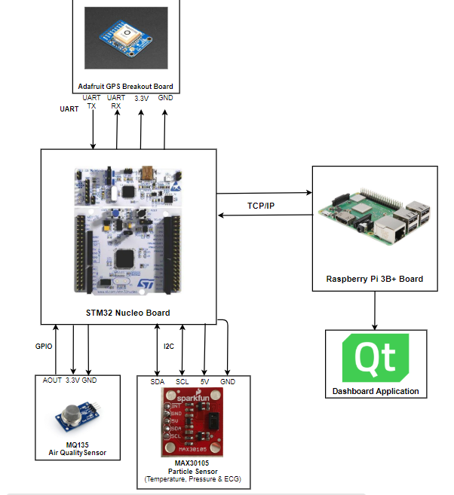

Our product shall consist of the air quality sensor to measure the gas concentration around the firefighter, where STM32 controller shall take the concentration value and warn about the hazards to the firefighter marshal, if the data exceeds certain limits. Temperature and ECG values are obtained from particle sensor to measure temperature around firefighter and heartbeat of the firefighter. The controller shall notify the firefighter marshal about the temperature exceeding above the dangerous limits. These data will be monitored by the marshal with the help of QT application, which gets the data over a network. The push-to-talk service shall be implemented directly using a microphone and a speaker.

In summary, our product highlights 2 new transformative and original feature compared to current state of the art products available in the market:

1. Our product incorporated a push-to-talk feature which helps firefighters communicate with each other at ease. This push-to-talk feature works on pressing a switch which could prove better than handling an additional device such as walkie talkie.

1. GPS Positioning and real-time tracking on the dashboard helps marshal to get the position of the other firefighters, who can provide appropriate instructions, thus ensuring firefighter’s safety.